** RAPHELA JUNIOR SCHOOL**

**LITERACY I A LESSON NOTES TERM III**

** PRIMARY THREE**

**THEME: HEALTH IN OUR DIVISION AND URBAN COUNCIL**

* **Health**

Health means general wellbeing of a person.

It also means being physically fit and free from diseases.

* **A disease**

A disease is an illness or disorder caused by infection or poor feeding.

* **Disease vectors**

Disease vectors are organisms which spread germs.

* **What is a germ?**

A germ is a tiny (micro) living organism which causes a disease.

Germs are very tiny and cannot be seen by our naked eyes but can only be seen using an instrument called **microscope.**

**The structure of a microscope**

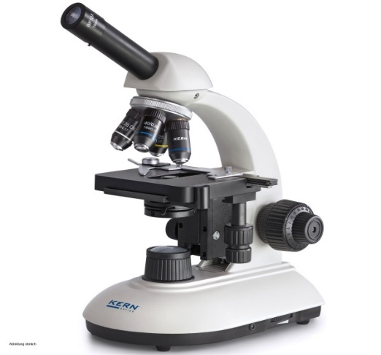

**Germs can be found in the following areas;**

* Air
* In blood, urine, saliva and faeces of sick people.
* On rotten or decayed materials.
* In dust bins and rubbish pits.
* In dirty toilets, pit latrines and urinals.
* In dirty food and water.

**Types of germs include;**

1. Bacteria
2. Virus
3. Protozoa
4. Fungi

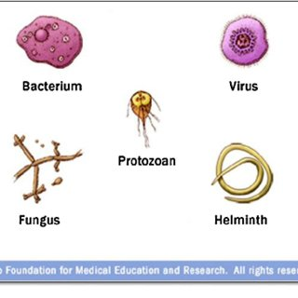

**How do germs spread?**

Germs spread in the following ways;

* Through air.
* Through insects and animal bites (vectors).
* Through open body cuts and wounds.
* Through drinking dirty water.
* Through body contact in a sick person.
* Through sharing clothes with a sick person.

**Diseases that spread through air include;**

* Tuberculosis
* Diphtheria
* Pneumonia
* Influenza
* Measles
* Mumps
* Chicken pox

**Diseases that spread through eating dirty food include;**

* Cholera
* Dysentery
* Typhoid fever

**We can control or prevent the above diseases through;**

1. Washing hands before eating food.
2. Covering left over food.
3. Spraying using insecticides to kill adult insect vectors**.**

**Activity: 1**

1. What term is used to mean the general wellbeing of a person?

______________________________________________________________________

1. Define the following terms;
2. A disease

______________________________________________________________________

1. Disease vectors

______________________________________________________________________

1. A germ

______________________________________________________________________

1. Why are people not able to see germs using naked eyes?

_______________________________________________________________________

1. Name the machine used to see germs.

_______________________________________________________________________

1. Give two places where germs can be found.
2. ______________________________________________________________________
3. _____________________________________________________________________
4. Outline any two types of germs.
5. ______________________________________________________________________
6. _____________________________________________________________________
7. Draw a structure of a virus in the space below.

**Disease vectors**

Disease vectors are living organisms that spread disease causing germs.

**Examples of common vectors include;**

* Mosquitos
* Houseflies
* Black flies
* Cockroaches
* Itch mites
* Lice
* Mad dogs
* Tsetse flies
* Ticks
* Fleas
* Snails
* Infected cats

**Pictures showing common vectors**

|  |  |  |
| --- | --- | --- |
| Mosquito Stock Illustrations – 14,298 Mosquito Stock Illustrations, Vectors  & Clipart - Dreamstime | **House Fly Clip Art** | **Free Black Fly Cliparts, Download Free Clip Art, Free Clip Art on Clipart  Library** |
| Mosquito | Housefly | Black fly |
| **My little cockroach tattoo. Can't wait x | Bug tattoo, Drawings, Bug art** | **Tsetse Fly Insect Sketch Engraving Vector Illustration. Scratch.. Royalty  Free Cliparts, Vectors, And Stock Illustration. Image 123653838.** | Louse Insect Stock Illustrations – 717 Louse Insect Stock Illustrations,  Vectors & Clipart - Dreamstime |
| Cockroach | Tsetse fly | Louse |
|  | Tick Illustration, Drawing, Engraving, Ink, Line Art, Vector Stock Vector -  Illustration of classic, engrave: 135060971 | Snail Achatina Snail Illustration, Drawing, Engraving, Ink, Line Art,  Vector Stock Vector - Illustration of cute, diet: 114041002 |
| Infected dog | Tick | Snail |

**Characteristics of vectors**

Vectors have the following characteristics;

* Some vectors feed on blood from other animals e.g. mosquitoes.
* They live in dirty places.
* Some vectors have hairy bodies like houseflies and cockroaches.
* Some vectors bite e.g. mad dogs, rats etc.
* Some vectors have piercing and sucking mouth part used for feeding.

**Houseflies**

* Houseflies are insects with hairy bodies.
* Houseflies are called vectors because they spread germs that cause diseases.
* A housefly carries germs on its hairy body.

**Houseflies spread germs in the following ways;**

* When they sit on dirty things and then come to our food.
* When they vomit saliva that contains germs on our food.
* When they defecate on our food.
* When they clean their bodies on our food.

**External parts of a housefly**

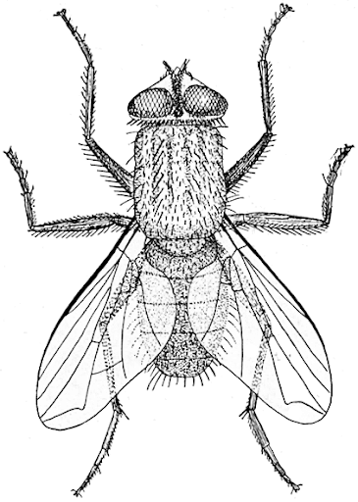

Compound eye

Thorax

Abdomen

Leg

Feeler

Wing

**Metamorphosis**

Metamorphosis refers to the developmental stages a living organism undergoes.

It is also called **life cycle.**

**There are two types of metamorphosis;**

1. Complete metamorphosis (it has four stages of development )
2. Incomplete metamorphosis (it has three stages of development)

**Life cycle of a housefly**

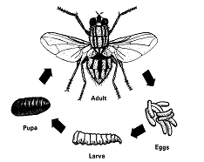

**Larva**

**Eggs**

**Adult (imago)**

**Pupa**

* A housefly under goes complete metamorphosis.
* An adult lays eggs in manure heaps, rotting bodies and faeces.
* The eggs hatch into larva, the larva (maggot) turns in to pupa after 1 day.
* After 4 – 5 days, the pupa turns to an adult housefly.
* An adult housefly is called imago.

**Diseases spread by a housefly include;**

* Cholera
* Typhoid
* Diarrhoea
* Dysentery
* Trachoma

**Activity: 2**

1. _________________________ are living organisms that spread disease causing germs.
2. Give any four common vectors in your environment.
3. ___________________________________________________________________
4. ___________________________________________________________________
5. ___________________________________________________________________
6. ___________________________________________________________________
7. Disease vectors spread ___________ that cause diseases.
8. Name the vectors given on the table below;

|  |  |
| --- | --- |
| **My little cockroach tattoo. Can't wait x | Bug tattoo, Drawings, Bug art** | Snail Achatina Snail Illustration, Drawing, Engraving, Ink, Line Art,  Vector Stock Vector - Illustration of cute, diet: 114041002 |
|  |  |

1. How is a housefly able to spread germs?

______________________________________________________________________

1. Mention any two characteristics of disease vectors.
2. _________________________________________________________________
3. _________________________________________________________________
4. In which way do houseflies spread germs?

______________________________________________________________________

1. Name the part used by a housefly for feeding.

______________________________________________________________________

1. What type of metamorphosis does a housefly undergo?

______________________________________________________________________

1. Give two diseases spread by a housefly.
2. _________________________________________________________________
3. _________________________________________________________________

**Cholera**

Cholera is disease caused by bacteria.

**Cholera is spread in the following ways;**

1. Through drinking contaminated water.
2. Through eating contaminated food.

**Signs and symptoms of cholera include;**

* Severe diarrhoea
* weakness and collapse
* Vomiting
* Dehydration

**We can prevent cholera in the following ways;**

* Drink clean boiled water.
* Cover leftover food.
* Wash hands before eating food.
* Wash hands with soap and clean water after visiting a latrine.
* Dispose human faeces in latrines.
* Take infected person to the hospital.

**Typhoid**

* Typhoid is also caused by bacteria.

**Signs and symptoms of typhoid include;**

* Constant fever with headache
* Increasing body pain
* Diarrhoea
* Abdominal pain

**Typhoid can be controlled or prevented in the following ways;**

* Drink clean boiled water.
* Dispose faeces in latrines or latrines.
* Wash hands with clean water and soap after using a toilet.
* Observe good food hygiene.
* Wash hands before and after eating food.

**Dysentery**

There are two types of dysentery namely;

1. Bacillary dysentery caused by **bacteria**
2. Amoebic dysentery caused by protozoa called **amoeba.**

**Dysentery spreads in the following ways;**

1. Through drinking contaminated water.
2. Through eating contaminated food.

**Sign and symptoms of diarrhea include;**

* Blood stained stool.
* Dehydration
* Fever
* Loss of appetite

**We can prevent dysentery by;**

* Using the latrines regularly.
* Washing hands before eating or touching food.
* Washing hands with soap and clean water after visiting the latrine
* Covering leftover food.
* Destroying all breeding places for houseflies.
* Keeping toilets or latrines clean.
* Sick people must be treated.

**Diarrhoea**

Diarrhoea is the frequent passing out of watery stool from a person.

**Diarrhoea is spread through;**

* Eating contaminated food.
* Drinking contaminated water.
* Eating food with dirty hands.

**Note that: Diarrhoea, dysentery, typhoid and cholera are diseases that are spread through 4F’s germ path.**

**Meaning of 4F’s**

4F’s is a germ path where germs are spread from faeces by flies to food and then to our fingers that we use to pick food when eating.

Therefore, 4F’s in full is; **faeces, flies, food and fingers**.

**Diagram showing 4F’s**

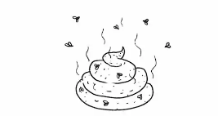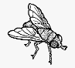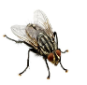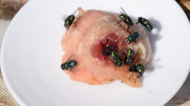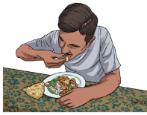

**Faeces**

**Flies**

**Food**

**Fingers**

**Activity: 3**

1. Name the germ that causes cholera.

______________________________________________________________________

1. How is cholera spread?

______________________________________________________________________

1. Give any one sign of each of the following diseases.
2. Cholera

___________________________________________________________________

1. Typhoid

___________________________________________________________________

1. Dysentery

___________________________________________________________________

1. Diarrhoea

___________________________________________________________________

1. What term is used to mean the frequent passing of watery stool from a person?

_____________________________________________________________________

1. State any two ways of controlling the spread of dysentery?
2. __________________________________________________________________
3. __________________________________________________________________
4. Write 4F’s in full.

______________________________________________________________________

1. Mention any three diseases that are spread through 4F’s.
2. ____________________________________________________________________
3. ____________________________________________________________________
4. ____________________________________________________________________
5. Outline two ways of preventing diseases spread through 4F’s.
6. ____________________________________________________________________
7. ____________________________________________________________________

**Dehydration**

Dehydration is a condition when the body does not have enough water.

**Causes of dehydration include;**

* Severe Diarrhoea
* Severe Vomiting

**Signs of dehydration include;**

* Sunken fontanelle
* Dry lips|
* Little or no urine
* A pinch on the skin goes back slowly
* Sunken eyes

**We can prevent diarrhoea through the following ways;**

* Leftover food should be covered.
* Wash hands before eating and after visiting toilet.
* Boil water for drinking.
* Use the toilet or latrine regularly.
* Wash fruits and vegetables.

**Treatment for diarrhoea and dehydration**

If a person is suffering from diarrhoea and dehydration;

* Give oral rehydration solution.
* Give a lot of fruit juice.
* Continue feeding the person with solid foods.

**ORS (oral rehydrated solution)**

* ORS is a solution made from salt and sugar.
* The oral rehydrated solution is obtained when the two solutes (salt and sugar) are properly dissolved in clean safe boiled water (a solvent)

**Note:** A solvent is a substance that dissolves a solute.

A solute is a substance that dissolves in a solvent e.g. sugar

A solution is a uniform mixture of a solute and a solvent.

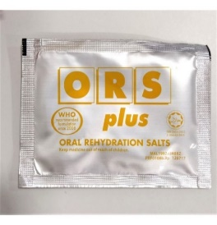

**ORS packed in sachets and bottles**

* Oral rehydration salts or Sugar salt solution can be made locally using salt, sugar and safe boiled water.
* The solution formed is called **sugar salt solution (SSS)**

**Why do we give ORS to a dehydrated person?**

* To prevent dehydration.
* To replace the lost fluids in the body (rehydration).

**How to prepare ORS packed in sachets**

* Wash hands with clean water and soap.
* Measure one litre of clean safe water into a clean container
* Open the sachet and pour the ORS into the water
* Stir the mixture until all the salts dissolve.

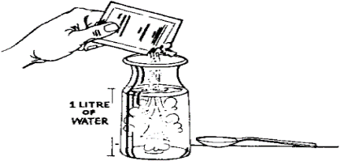

How to prepare ORS

**NB –** don’t boil the solution after preparing or stirring.

**How to make ORS (Sugar salt solution) locally**

**Items used:**

* 1 litre cup or 1litre bottle
* salt
* sugar
* safe clean water
* clean container
* tea spoon

**Steps to be followed**

* Wash hands with clean water and soap.
* Measure one litre of cool boiled water into a clean container
* Add one leveled tea spoon of salt and the eight leveled tea spoons of sugar into the one measured litre of water.
* Stir the mixture to form a uniform solution.

|  |  |
| --- | --- |
| **How to make Salt Sugar Solution (SSS) or (ORS)** | |
| Science Experiments for Kids | HowStuffWorks | Substance | Braintor Library |
| Stir the mixture properly | The solution formed (sugar + water) |

**Note:**

* Solution should be served within twenty-four hours (1 day) after that time the solution goes bad.

**Activity: 4**

1. What does the term dehydration mean?

______________________________________________________________________

1. Mention two major causes of dehydration.
2. ____________________________________________________________________
3. ____________________________________________________________________
4. How can one tell that a person dehydrated?

______________________________________________________________________

1. State the best treatment for dehydration.

______________________________________________________________________

1. Write **ORS** in full.

______________________________________________________________________

1. Give a reason why ORS is given to a dehydrated person.

______________________________________________________________________

1. Define rehydration.

______________________________________________________________________

1. Why is it advised to wash hands with clean water and soap before starting to prepare **ORS**?

______________________________________________________________________

1. What is the use of the spoon during ORS preparation?

______________________________________________________________________

1. Name two solutes used to make **ORS** locally.
2. ________________________________________________________________
3. ________________________________________________________________
4. State two uses of water when making ORS.
5. ________________________________________________________________
6. ________________________________________________________________

**Trachoma**

* Trachoma is a disease caused by a bacterium called **chlamydia.**
* It affects the eyes**.**
* The eyes turn red.
* Trachoma is the disease spread by a housefly but it is not spread through drinking dirty water or through 4F’s.

**Trachoma spreads in the following ways;**

* A housefly lands on the eyes of a sick person then later on the eyes of a normal person.
* Sharing towels or handkerchiefs with a sick person and then transfer the hands to your eyes.
* Sharing the same basin of water with a sick person.

**Signs and symptoms of trachoma are;**

* Eyes become red and itch a lot.
* Water comes from the eyes.
* The eyelids swell.
* Pain while looking at light.

**We can prevent trachoma in the following ways;**

* Avoid sharing things like the basin, handkerchiefs with infected people.
* If one is showing is showing signs, he/she should be taken to the hospital.

**Mosquitoes**

* Mosquitoes are insects.
* They are also called vectors because they spread disease causing germs.

**Types of mosquitoes**

There are three types of mosquitoes namely;

* The anopheles mosquito
* Culex mosquito
* Tiger (aedes) mosquito

**Diagrams showing the three types of mosquitoes**

|  |  |  |
| --- | --- | --- |
| Anopheles Mosquito Stock Illustrations – 738 Anopheles Mosquito Stock  Illustrations, Vectors & Clipart - Dreamstime | Natural mosquito repellent you can make with toilet paper!! | Mosquito  repellent, Spider bites pictures, Mosquito yard spray | Nature, Aedes Aegypti Mosquito stilt, top view. Ideal for informational and  institutional related sanitation and care — Stock Vector © Lcosmo #100817404 |
| Female anopheles | Culex mosquito | Aedes mosquito |

**Note:** The above three types of mosquitoes carry germs that spread different diseases as shown in the table below.

**Types of mosquitoes and the diseases they spread**

|  |  |
| --- | --- |
| **Mosquito** | **Disease** |
| Female anopheles mosquito | Malaria |
| Culex | Elephantiasis |
| Aedes mosquito | Dengue fever or yellow fever |

**Note the following;**

* Malaria is caused by plasmodia germs.
* Yellow fever is caused by a virus.
* Elephantiasis is caused by filarial worms.

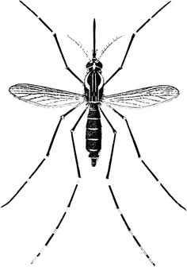

Abdomen

Proboscis

Antenna

Wing

Thorax

Head

Leg

**External features of a mosquito**

* The mosquito has three main body parts namely; head, thorax and abdomen.
* The head has pair of compound eyes, proboscis, and pair of antenna.
* The thorax have wings and three pairs of legs.
* The abdomen is long, thin and segmented.
* The spiracles on the abdomen are used for breathing.

**Activity: 5**

1. Mention the common disease of the eyes that is spread by a housefly.

_______________________________________________________________________

1. Mention any two signs of trachoma.
2. ______________________________________________________________________
3. ______________________________________________________________________
4. State any one way of preventing the spread of trachoma.

_______________________________________________________________________

1. Why are mosquitoes called vectors?

_______________________________________________________________________

1. Name the type of mosquitoes shown below.

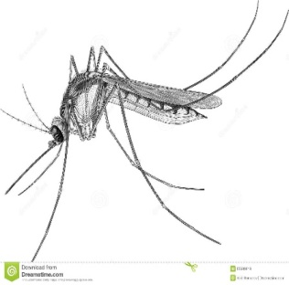

__________________________________________________

1. Name the vector that causes elephantiasis.

_______________________________________________________________________

1. How does female anopheles mosquito spread germs that cause malaria?

_______________________________________________________________________

1. Outline the three main body parts of a mosquito.
2. ______________________________________________________________________
3. ______________________________________________________________________
4. ______________________________________________________________________
5. Why do mosquitoes have proboscis?

_______________________________________________________________________

1. Give two body parts of a mosquito that found on the thorax.

_______________________________________________________________________

**Anopheles mosquitoes**

* Female anopheles mosquito spreads germs that case **malaria**.
* The male anopheles mosquito does not spread germs because it feeds on plant juices and nectar but not human blood.
* Female anopheles mosquito lays eggs in stagnant water.
* It spreads malaria through its bites.

**Diagram of female anopheles mosquito**

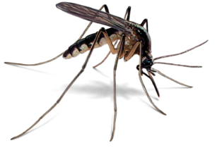

**Signs of malaria include the following;**

* Tiredness or general body weakness.
* High body temperature (fever)
* Headache.
* Shivering and chattering of teeth.
* Pain on the joints.
* Rapid breathing and high heartbeat.
* Sweating over a period of 2 – 4 days.
* Abdominal pain, diarrhea and vomiting.

**Prevention and control of malaria**

We can prevent or control malaria in the following ways;

* Draining stagnant water.
* Sleeping under treated mosquito nets.
* Slashing all the long grass in our compound.
* Allowing much light into the house.
* Spraying with insecticides to kill adult mosquitoes.

**Treatment of malaria**

Use medicine such as;

* Chloroquine
* Lumartem
* Quinine
* Coartem

**Question:** Mention some of the herbal medicine used to treat malaria.

**Pictures showing medicine used to treat malaria**

|  |  |  |
| --- | --- | --- |
| **Hydroxychloroquine: The special drug Trump and the world are dialling PM  Modi for** | Picture of a smart blister pack showing resemblance to regular blister... |  Download Scientific Diagram | Buy Quinin, Quinine Sulphate ( Generic Quinoc-s ) Online |
| **Chloroquine** | **Coartem** | **Quinine** |

**We can also use local herbs like;**

* Omululuuza (Buganda)
* Aloe Vera (Ekigagi - Luganda)

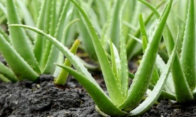

Aloe Vera

**The life cycle of female anopheles mosquito**

**Note:**

* Lifecycle can be defined as the developmental stages of an organism.
* It can also be called **metamorphosis**.
* Female anopheles mosquito undergoes four stages of development as shown below.

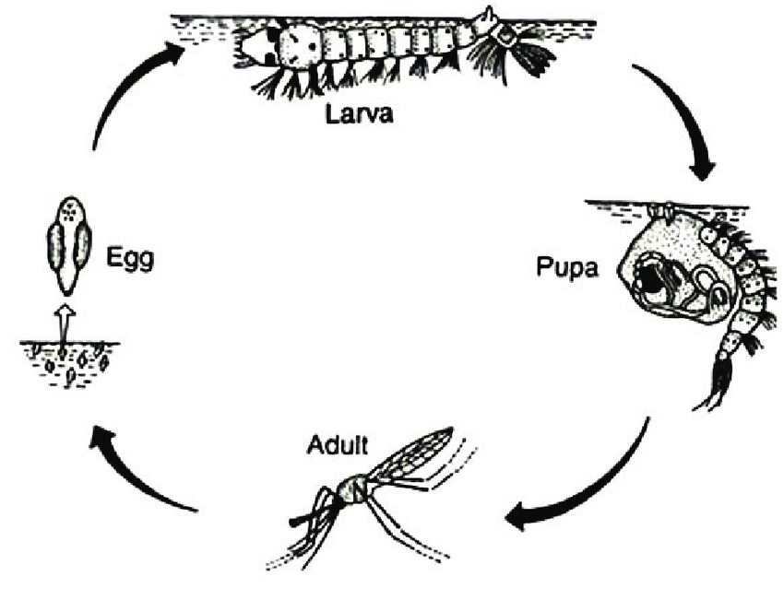

**Life cycle of the anopheles mosquito**

* The four stages of development above are called **complete** **metamorphosis.**
* The larva of a mosquito is called **wriggler**.

**Activity: 6**

1. What causes malaria?

______________________________________________________________________

1. Mention any three signs and symptoms of malaria.
2. ___________________________________________________________________
3. ___________________________________________________________________
4. ___________________________________________________________________
5. How can we prevent the spread of malaria at home?

______________________________________________________________________

1. State the treatment that you can give to aperson suffering from malaria?

______________________________________________________________________

1. What name is given to the larva stage of a mosquito?

______________________________________________________________________

1. Give one herb that is used to treat malaria in your area.

______________________________________________________________________

**Culex or tiger mosquito**

Culex mosquito spreads a worm which causes elephantiasis. The disease makes the legs to grow big like that of an elephant.

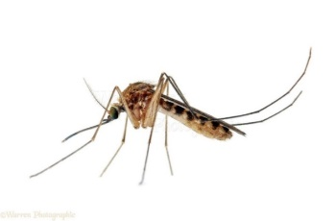

**Diagram of culex mosquito**

**Aedes mosquito**

* The aedes mosquito spreads a virus that causes either yellow fever or dengue fever.
* The virus is spread through stagnant water that contains the eggs of aedes mosquito.

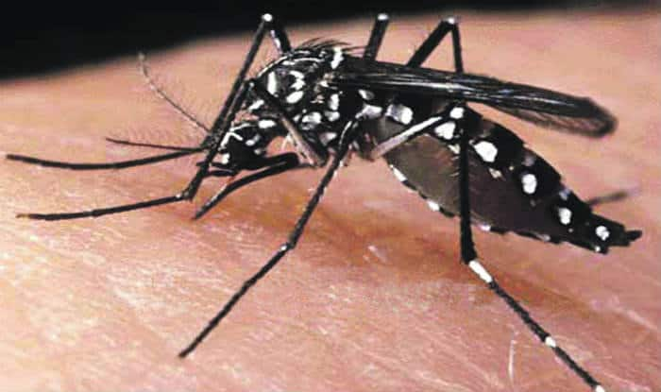

**Aedes mosquito**

**Work to enjoy**

1. What causes elephantiasis?

______________________________________________________________________

1. Names the disease that is caused by aedes mosquito?

______________________________________________________________________

1. Where do mosquitoes lay their eggs?

______________________________________________________________________

1. Why does female anopheles mosquito feed on blood?

______________________________________________________________________

1. Draw a culex mosquito in the space below.

**Tsetse fly**

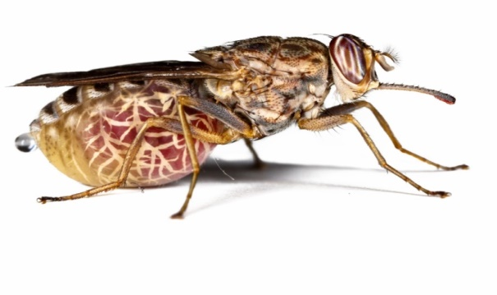

**The structure of a testes fly**

* A tsetse fly spreads a germ which causes sleeping sickness in people and nagana in animals.
* Sleeping sickness and nagana are transmitted by female tsetse fly which feeds on blood. The male tsetse fly does not feed on blood; it feeds on certain plant juices.

**Sleeping sickness**

* Sleeping sickness is a disease spread by tsetse flies.
* It is a disease caused by protozoa.

**Signs and symptoms of sleeping sickness include;**

* Dullness
* Prolonged fever
* Weakness
* Loss of body weight
* Laziness/sleepy

**Prevention and control of sleeping sickness**

* Spray chemicals to kill adult tsetse flies
* Use tsetse fly traps to trap adult tsetse flies
* Treat the infected persons in the hospital
* Clear bushes around homes

**Life cycle of a tsetse fly**

* Tsetse fly under goes a complete metamorphosis/four stages of development.
* Eggs
* Larva
* Pupa
* Adult

**Note;** the eggs develop in the abdomen and it lays the larva.

**A diagram showing the life cycle of a tsetse fly**

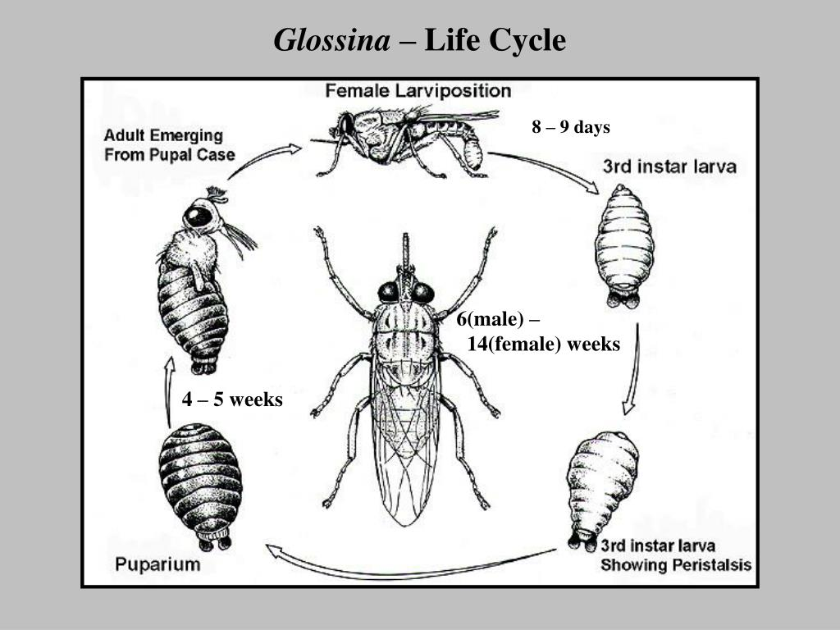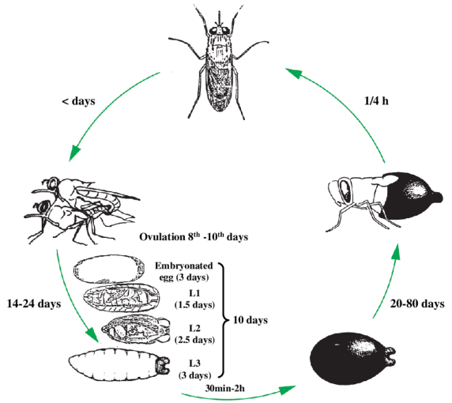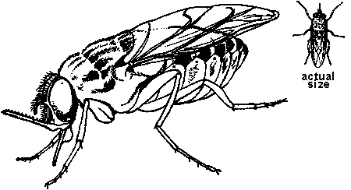

**A female tsetse fly lays mature eggs**

**(Larvae)**

**Larva**

**Pupa**

**Adult**

**Tsetse flies breed in the following places;**

* Among vegetation or dry leaves.
* Sandy areas along river banks.
* Open grass land

**We can control tsetse flies buy;**

* Spraying insecticides to kill adult tsetse flies
* Using tsetse fly traps
* Clearing bushy areas around our homes.
* Do not build your house near a forest.

**Cockroaches**

* A cockroach is a flat brown insect.
* It has three main body parts that is head, thorax and abdomen.
* They move at night looking for food.

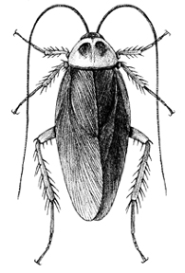

**The structure of a cockroack**

**Cockroaches hide in dark places like;**

* + Cupboards
  + Boxes
  + Bookshelves
  + Latrines
  + Cracks on walls

**How do cockroaches spread germs?**

* By carrying germs on its body to the food or water.

**Cockroaches carry germs which cause the following diseases**

* Polio
* Typhoid
* Leprosy
* Food poisoning
* Amoebic dysentery

**The life cycle of a cockroach**

* The female lays eggs in an egg case containing about 16 eggs.
* The eggs hatch into nymphs which look exactly like the adults but no wings
* After few days it changes into an adult with fully developed wings.

**Note;**

* A cockroach undergoes **incomplete lifecycle**
* This is because it has three stages of development.

**Question**: Apart from a cockroach, give any other insect that undergoes incomplete metamorphosis.

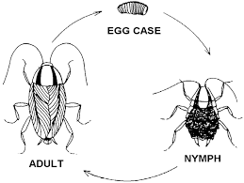**A diagram showing the life cycle of a cockroach**

**We can keep away or control cockroaches by:**

* Throwing away left-over pieces of food
* Destroying those using insecticides.
* Empty cupboards and clean them often.
* Allow much light in a room.

**A part from spreading germs, cockroaches can also;**

* Destroy papers and books.
* Eat furniture.

**Activity:** **7**

1. Tsetse flies spread ………………………………to human beings. (**complete** **the sentence**)
2. Mention two signs of sleeping sickness.
3. ____________________________________________________________________
4. ____________________________________________________________________
5. Write down two ways of how to control nagana in animals.
6. ____________________________________________________________________
7. ____________________________________________________________________
8. Name the first stage of development in cockroaches.

______________________________________________________________________

1. Mention three places where we can find cockroaches.
2. ____________________________________________________________________
3. ____________________________________________________________________
4. ____________________________________________________________________
5. Write four ways of preventing cockroaches.
6. ___________________________________________________________________
7. ___________________________________________________________________
8. ___________________________________________________________________
9. ___________________________________________________________________
10. Underline the diseases spread by cockroaches

**polio** **high temperature** **typhoid** **leprosy**

**TICKS**

* Ticks are parasites because they suck blood from animals.
* Ticks have eight legs.
* Ticks don’t have wings.
* Ticks have two main body parts.
* Ticks go through an incomplete lifecycle.

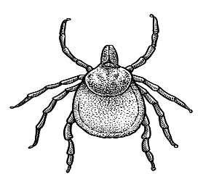

**The structure of a tick**

**Places where ticks live**

* Bushes/grass

**Note;**

Ticks spread **typhus fever** to people.

**Control of ticks**

Ticks can be controlled in the following ways;

* Spraying the animals with chemicals.
* Hand picking and killing ticks.
* Do not lie on grass where animals graze.

**Rat fleas**

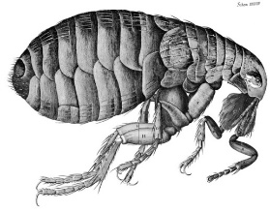

**The structure of a rat flea**

Rat fleas spread bacteria which causes disease called **bubonic plague** from an infected rat to human beings.

**What is the danger of rats besides destroying farmers’ crops?**

Rats carry fleas that spread bubonic plague to human beings.

**Signs of bubonic plague include;**

* Swelling in the neck and armpits.

**Rat fleas can be prevented in the following ways;**

* Kill rats in your compound.
* Spray houses with insecticides to kill fleas.
* In case of an outbreak, people should take anti-plague vaccination.

**Itch mites**

* Itch mites are like ticks.
* They have eight legs.
* They spread scabies.

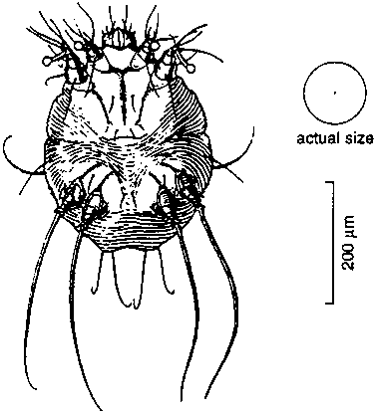

**The structure of a rat flea**

**Signs of scabies include;**

* Itching and scratching the skin.

**NB:** Scabies affect the skin between fingers, toes and ankles.

**Scabies spread through;**

* Body to body contact e.g. shaking hands with an infected person.
* Sharing clothes, basins, towels and sponges with an infected person.
* Sharing beddings with an infected person.

**How can we control or prevent scabies?**

* Wash clothes of an infected person with hot water and soap.
* Do not share clothes with an infected person.
* Wear clean clothes.
* Avoid sharing basins or towels with an infected person.
* Avoid sharing beddings with an infected person.

**Activity: 8**

* + 1. Why are ticks called vectors?

______________________________________________________________________

* + 1. Give any one place where ticks are found.

______________________________________________________________________

* + 1. Outline three ways of controlling ticks.

1. ___________________________________________________________________
2. ___________________________________________________________________
3. ___________________________________________________________________
   * 1. What causes bubonic plague?

______________________________________________________________________

* + 1. Mention any two ways of controlling rat fleas at home.

1. ___________________________________________________________________
2. ___________________________________________________________________
   * 1. Name the vector that spreads scabies.

______________________________________________________________________

* + 1. Why does scabies cause scratching of the skin?

______________________________________________________________________

* + 1. State two ways scabies can spread from one person to another?

______________________________________________________________________

* + 1. How can we control the spread of scabies?

1. ___________________________________________________________________
2. ___________________________________________________________________
3. ___________________________________________________________________

**Lice**

* Lice are small wingless vectors.
* Lice feed on blood which they suck from people and other animals.

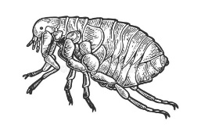

**The structure of a louse**

**Types of lice**

* **Body lice**

Body lice live in dirty clothes.

Their eggs are found in seams and folds of clothes.

* **Head lice**

They live in dirty hair on our heads.

People get them by sharing combs and beds with infected people.

* **Crab lice**

They live in hair which grows around the private parts.

They are spread when the male and female partners join their private parts during sexual intercourse.

**A table showing types of lice**

|  |  |  |
| --- | --- | --- |
| Body Louse Stock Illustrations – 59 Body Louse Stock Illustrations, Vectors  & Clipart - Dreamstime | C:\Users\Teachers\AppData\Local\Microsoft\Windows\INetCache\Content.MSO\6C5D1BD8.tmp | Pubic lice |
| Body louse | Head louse | Crab (pubic) louse |

**Note;** Lice spread diseases like **relapsing fever** and **typhus fever**.

**Prevention of lice**

Lice can be prevented by;

* Trimming of hair on our body.
* Avoiding sharing combs with other people.
* Ironing clothes.
* Bathing daily with antiseptic soap such as protex, skin guard, detol etc.
* Use fine combs to remove dead lice and the eggs.

**Bedbugs**

* Bed bugs are flat red brown insects without wings.

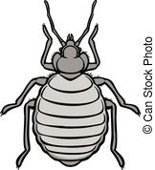

**The structure of a bedbug**

**Where bedbugs live**

* In cracks of walls.
* In cracks of floors.
* In beddings.
* Bedbugs become active at night by sucking blood hence causing irritation to the body.
* Bedbugs protect themselves from enemies by producing a bad smell when touched.
* They do not spread any disease.

**How can bedbugs be controlled?**

* Spread all beddings under the sun to kill bedbugs.
* Pour hot water on furniture like beds to kill adult bedbugs.
* Spray insecticides on cracks of floors/walls to kill adult bedbugs and their nymphs.
* Wash beddings and iron them regularly.

**Activity: 9**

* + - 1. Name one characteristic that makes a louse to be a vector.

______________________________________________________________________

* + - 1. Give any three types of lice.

1. ___________________________________________________________________
2. ___________________________________________________________________
3. ___________________________________________________________________
   * + 1. Where can crab lice live in the human body?

______________________________________________________________________

* + - 1. How can one prevent lice?

1. ___________________________________________________________________
2. ___________________________________________________________________
   * + 1. State a reason why bedbugs produce bad smell when touched.

______________________________________________________________________

* + - 1. How can bedbugs be controlled?

1. ___________________________________________________________________
2. ___________________________________________________________________
   * + 1. Draw a bedbug in the space below.

**Water snail**

* Water snails are vectors because the worm which causes **Bilharziasis** develops in them.
* The worm is called a **blood fluke**.
* The worms live in the bladder, small intestine or large intestine of human beings.
* The eggs of the worms leave the sick person’s body through urine or faeces and reach water bodies.
* In water bodies they develop in to larvae called **cercariae**.
* The larvae enter in a water snail for another stage of development.

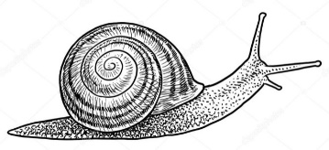

**The structure of a water snail**

**How is bilharziasis spread?**

* When cercariae penetrate the skin during swimming.
* Drinking water containing eggs/cercariae (larvae).

**Name the body parts where blood flukes live in people.**

1. Bladder
2. Intestines
3. liver

**Which bad practice spreads biharziasis?**

* Urinating in water sources
* Defecating in water bodies.

**Signs and symptoms of bilharzia include;**

* Blood in the urine and stool.
* Enlargement of the liver and the spleen.

**Prevention of bilharzia**

* Swim in well treated water.
* Use latrines for urinating and defecating.
* Boil water for drinking.

**Treatment of bilharziasis**

* Go to a doctor straight away if you have blood in urine or stool.

**Activity: 10**

1. Fill in the blank space using the word given in the bracket.

Snails spread _____________________ that cause bilharziasis. (**warmth**, **wormth**, **warms**, **worms).**

**Write ‘true’ or ‘false’**

1. Defecating blood stained stool is a sign of bilharziasis.

______________________________________________________________________

1. Worms that cause bilharzia live in the blood of an infected person.

______________________________________________________________________

1. Boiling drinking water can help control bilharziasis.

______________________________________________________________________

1. Drinking contaminated water and swimming in contaminated water exposes one to bilharzia.

______________________________________________________________________

1. Name the worm that causes bilharziasis.

______________________________________________________________________

1. What do we call the larva stage of a blood fluke?

______________________________________________________________________

**Infected dogs**

* Dogs are animals kept in our homes as pets.
* Dogs should be vaccinated because they can spread **rabies**.
* Dogs can get rabies from other **infected dogs**, **foxes** and **jackals**.
* Such dogs infected with rabies are called **rabid dogs**.

**How can dogs spread rabies?**

* Through the bites of an infected dog.

**Signs and symptoms of rabies include;**

* The dog becomes uncontrollable and mad.
* The infected person starts barking like a dog after six months from the day of infection.

**Prevention of rabies**

Rabies can be prevented through;

* Vaccinating all dogs and cats.
* Killing all suspected mad dogs and cats.
* If a person has been bitten by a dog which was not vaccinated, the person should be taken to the hospital as soon as possible.

**Note;**

* Infected cats can also spread rabies
* Rabies can take six months in the body before showing its signs and symptoms.

**Prevention and controlling vectors**

Vectors can be controlled through;

* Keeping proper hygiene.
* Covering food.
* Spraying using insecticides to kill adult vectors.
* Sweeping our houses and compounds.
* Slashing bushy areas.
* Digging around the houses.
* Sleeping under treated mosquito nets.
* Draining or oiling stagnant water.

**Summary of diseases spread through insects and animal bites**

These germs are spread when an insect or an infected animal carrying germs bites a person.

**They include:**

* Malaria is spread by an infected female anopheles mosquito.
* Elephantiasis is spread by a female Culex mosquito.
* Yellow fever is spread by a female Aedes mosquito.
* Sleeping sickness is spread by a tsetse fly.
* Plague is spread by rat fleas.
* Typhus fever is spread by ticks.
* River blindness is spread by the black flies.
* Rabies is spread by infected dogs.

**Germs spread through open cuts and wounds**

* These are germs which can enter the body through fresh cuts.
* Such germs majorly cause **tetanus**.

**Germs spread through wounds and open cuts can be prevented by:**

* Washing hands with clean water and soap.
* Avoid touching open wounds with bare hands.

**Diseases spread through body contact are;**

* Ring worm infection
* Leprosy
* Scabies

**Diseases spread through contact with infected blood**

* HIV/AIDS

**Other diseases spread through cuts and wounds include;**

* HIV/AID

**Activity: 11**

* + - * 1. How is rabies spread?

______________________________________________________________________

* + - * 1. Give the main reason why dogs are vaccinated.

______________________________________________________________________

* + - * 1. How can we prevent rabies in our communities?

______________________________________________________________________

* + - * 1. Outline four ways of preventing disease vectors.

1. ________________________________________________________________
2. ________________________________________________________________
3. ________________________________________________________________
4. ________________________________________________________________
   * + - 1. Give one disease that is spread through;
5. Open cuts and wounds

__________________________________________________________________

1. Body contact with infected person

__________________________________________________________________

1. Contact with infected blood

__________________________________________________________________

1. Eating contaminated food

__________________________________________________________________

* 1. Write **HIV** in full.

____________________________________________________________________

**New words learnt**

* vectors
* plasmodia
* signs
* symptoms
* temperature
* appetite
* diarrhoea
* attacks
* prevention
* incomplete
* larva
* host
* life cycle
* stagnant
* draining
* insecticides
* fumigation
* bacterium
* control
* isolate
* sunken
* complete
* dizziness
* flies
* characteristics
* oral
* rehydration
* solution
* solute
* solvent
* dysentery
* dehydration
* wastes
* trypanosome

**HIV AND AIDS**

**Concepts of HIV and AIDS**

* HIV stands for Human Immunodeficiency virus.
* HIV is a virus which causes AIDS
* AIDS stands for Acquired Immune Deficiency Syndrome.
* HIV destroys the white blood cells.
* A person with HIV starts suffering from various diseases and illnesses when the white blood cells have been destroyed.

AIDS is a lifelong threatening condition which develops after many years when a person has been infected with HIV.

**The spread of HIV/AIDS**

HIV/AIDS is spread through the following ways;

* Having unprotected sex with infected people.
* From infected mother to child through breast feeding.
* From infected mother to child when giving birth.
* Through infected blood transfusion.
* Through sharing sharp objects like razor blades and safety pins with an infected person.
* During accidents.
* Through some cultural practices like circumcision and genital mutilation.

**HIV/AIDS cannot be spread include the following ways;**

1. Shaking hands with infected people.
2. Sharing food with infected people.
3. Playing with infected people.

**Signs and symptoms of HIV and AIDS**

A person having HIV/AIDS may show the following signs;

* Chronic cough
* Oral thrush
* Loss of body weight
* Skin rash
* Severe night sweating
* Persistent diarrhea
* Loss of appetite
* Herpes zoster

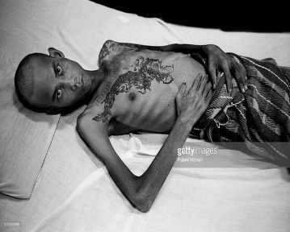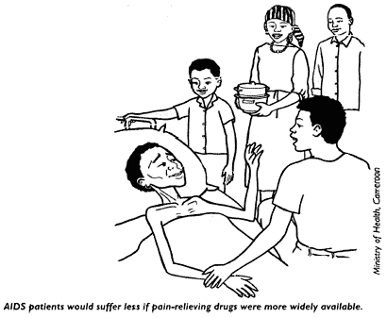

**Pictures showing HIV/AIDS victims**

**Effects of HIV/AIDS**

HIV/AIDS affects an individual, a family and the community.

* **A person infected with HIV/AIDS is affected in these ways;**
* HIV/AIDS weakens the body immunity.
* HIV/AIDS kills.
* It leads to poverty.
* It causes worries to a person who is suffering (stigmatization)
* It leads to loss of appetite for food and body weight.
* The person is psychologically tortured.
* **HIV/AIDS can affect ones’ family in the following ways;**
* It leads to school drop outs incase both parents die.
* The family may lose its property.
* Children become orphans when parents die.
* **HIV/AIDS can also affect the community in the following ways**;
* It leads to loss of skilled people in the community like teachers, doctors, etc. who may be of great importance in the community.

**Ways of caring for HIV/ AIDS patients**

HIV/AIDS patients need the following care;

* Guiding and counseling them.
* Feeding them on a balanced diet.
* Having regular physical exercise.
* Encouraging them to have enough rest and sleep.
* Encouraging them to swallow ARVs( Anti-Retroviral drugs)
* Avoiding stigmatization.
* Encouraging them to take medicine on time.
* Advising them to visit the doctors whenever they are sick.
* Helping the patients to clean by combing hair, washing for them etc.
* Advise the patients to sleep under treated mosquito net.
* Encouraging them not to drink alcohol or smoke cigarettes.

**How to prevent HIV/AIDS**

AIDS is deadly and has no cure therefore; the following can be done to control its spread;

* Avoid sharing sharp objects like safety pins, razor blades among others.
* Blood for transfusion should be screened.
* Abstinence from sex until one is married.
* Being faithful to one sexual partner.
* Use condoms or have protected sex.
* Wearing gloves when helping HIV/AIDS patient.
* Educating people on the ways HIV is spread.
* Punishing people who spread HIV/AIDS intentionally to others.
* Using advice from PIASCY messages on assemblies and on the compounds.
* Always go for HIV blood test.

**Read and answer**

Qtn: **How can a P3 child prevent him or herself from getting HIV and AIDS?**

* By abstaining from sex.

Qtn: **Apart from preventing one from contacting HIV/AIDS, mention any three other importance of abstaining from sex.**

* It prevents early marriages.
* It also helps to prevent school dropouts.
* Abstaining from sex controls early pregnancies.

Qtn**: Why should sharp objects be sterilized before use?**

* To kill germs that might have contaminated them.

**Activity: 12**

1. What do the following stand for:
2. HIV: _______________________________________________________________
3. AIDS: ______________________________________________________________
4. Name the virus that causes AIDS.

______________________________________________________________________

1. What is AIDS?

______________________________________________________________________

Write ‘**Yes**’ or ‘**No**’

1. HIV/AIDS is spread through blood transfusion if the blood donor is affected. _____________________________________________________________
2. Sharing food with a person who is living with AIDS can spread the disease to another person. ____________________________________________________
3. How can HIV/AIDS affect;
4. An individual

____________________________________________________________________

1. Family

____________________________________________________________________

1. Community

____________________________________________________________________

1. How can you care for HIV/AIDS patient?
2. ___________________________________________________________________
3. ___________________________________________________________________
4. ___________________________________________________________________
5. Draw your self-helping HIV/AIDS patient in the space below.

**PIASCY messages**

* **PIASCY** in full is Presidential Initiative on AIDS Strategy for Communication to the Youth.
* This programme was started by the president to make the youth aware of how HIV/AIDS spreads and how it’s controlled or prevented.
* As children at school, we can learn PIASCY messages during assemblies, clubs, and in classes.

**The following are some of the PIASCY messages;**

1. Say No to gifts for sex.
2. Abstain from sex until marriage.
3. Children have rights and responsibilities.
4. Premarital sex is risky.
5. Say no to sex.
6. Avoid bad touches.
7. Avoid lifts from strangers.
8. Avoid walking alone at night.
9. Test for HIV.
10. HIV damages the body.
11. AIDS has no age limit.
12. Stay in school.
13. People with HIV need care and support.

Qtn**: How is PIASCY important to you as a P3 child?**

* Helps to know more about HIV and AIDS.

**Work to enjoy**

List down some of the PIASCY messages that you would like to have in your school compound.

1. **____________________________________________________________________**
2. **____________________________________________________________________**
3. **____________________________________________________________________**
4. **____________________________________________________________________**
5. **____________________________________________________________________**
6. **____________________________________________________________________**
7. **____________________________________________________________________**

**Activity: 13**

1. Write PIASCY in full.

___________________________________________________________________

1. Write any five PIASCY messages.
2. _________________________________________________________________
3. ________________________________________________________________
4. ________________________________________________________________
5. ________________________________________________________________
6. ________________________________________________________________
7. Mention any two lessons that you learn from PIASCY messages.
8. _________________________________________________________________
9. ________________________________________________________________
10. How can you as a Primary three child benefit from PIASCY messages?
11. ________________________________________________________________
12. ________________________________________________________________
13. ________________________________________________________________
14. State any two PIASCY messages in your school compound that can help you as a P3 child to control HIV and AIDS.
15. ________________________________________________________________
16. ________________________________________________________________

**THEME: ENERGY IN OUR SUB-COUNTY /COUNTY**

**Sub theme: Sources of energy**

What is energy?

**Energy** is ability to do work.

Or energy is a capacity of doing work.

People need energy to do work, let us look at the examples below;

* A boy slashing the compound needs energy.
* A man cutting a tree needs energy.
* A boy riding a bicycle needs energy, etc.

**Note**; most of the energy a human body needs to do work comes from the food we eat.

**Some the activities that we do using energy**

|  |  |
| --- | --- |
| The economics of sustainable agricultural intensification, Benin - Altus  Impact | **What Tempo Runs and Threshold Running Are All About** |
| **Slashing** | **Running** |
| **HD wallpaper: person riding bicycle at daytime, cyclist, professional road  bicycle racer | Wallpaper Flare** | **Kids playing football 2 - The Soccer Store Blog** |
| **Riding a bicycle** | **Playing** |

**Sources of energy**

There are two sources of energy.

1. Natural sources of energy (God made sources)
2. Artificial sources of energy (man-made sources )
3. **Natural sources of energy**

Natural sources of energy are sources of energy made by God.

The examples of natural sources of energy include the following;

* wind

**THINK**

**What are the uses of these natural sources of energy?**

* water
* sun
* minerals
* plants
* animals
* food

|  |  |  |
| --- | --- | --- |
| **Free Sun Drawing, Download Free Clip Art, Free Clip Art on Clipart Library** | Restore Pakistan's rivers to handle droughts, floods and climate change |  Opinion | Eco-Business | Asia Pacific | **Eucalyptus Forest In Thailand, Plats For Paper Industry Stock Photo,  Picture And Royalty Free Image. Image 14212126.** |
| The sun | Water | Plants |

**Activity: 14**

* + 1. Define energy?

_______________________________________________________________________

* + 1. Give any four activities done by a man that require the use of energy.

1. ____________________________________________________________________
2. ____________________________________________________________________
3. ____________________________________________________________________
4. ____________________________________________________________________
   * 1. Outline two sources of energy.
5. ____________________________________________________________________
6. ____________________________________________________________________
   * 1. Why is wind regarded as a natural source of energy?

_______________________________________________________________________

* + 1. What are artificial sources of energy?

_______________________________________________________________________

* + 1. Name any four natural sources.

1. ____________________________________________________________________
2. ____________________________________________________________________
3. ____________________________________________________________________
4. ____________________________________________________________________
   * 1. Draw any one activity that requires the use of energy in the space below.

**Wind as a natural source of energy**

Wind is a moving air.

**How is wind a source of energy?**

1. Wind is used for sailing boats on lakes, rivers among others.
2. It is used for driving wind mills.
3. It is used for winnowing harvested cereals e.g. millet, rice, beans, maize.
4. Wind moves kites, parachutes, balloons among others.
5. Wind dries clothes.

**Uses of wind**

|  |  |
| --- | --- |
| **Cruising sailboat - Morozov-30 Meduza - Morozov Yachts - motorsailer / open  transom / aluminum** | **What are the sizes of the blades on a windmill? - Quora** |
| For sailing boats | For driving windmills |
| **Parachute sport** | **Winnowing- When you use the force of the wind, to remove the chaff and  other wastes, from the grain. | Chaffed, Sombrero, Panama hat** |
| For moving parachutes | For winnowing |

**Water as a natural source of energy**

Water is a source of energy because of the following reasons;

* Fat flowing water in rivers is used to generate hydroelectricity power (H.E.P)
* Water is used at home for cooking, washing (domestic use)
* It is used for cooling machines
* Water is used by farmers for irrigation.

|  |  |
| --- | --- |
| Hydro feasibility study in Tasmania receives funding | Infrastructure  Magazine | Modernization of Irrigation Systems in Full Swing | Financial Tribune |
| **Generation of hydroelectricity power** | **Irrigating crops** |

**The sun**

The sun is the main natural source of heat and light.

**Forms of energy from the sun**

* heat energy
* light energy
* solar energy

**The sun as a source of energy**

* The light from the sun helps us to see.
* The sun dries our clothes.
* It helps farmers to dry harvested seeds.
* It helps in rain formation.
* It provides solar electricity.
* The sun helps plants to make their own food (photosynthesis)

**The diagram below shows how solar electricity is got from the sun**

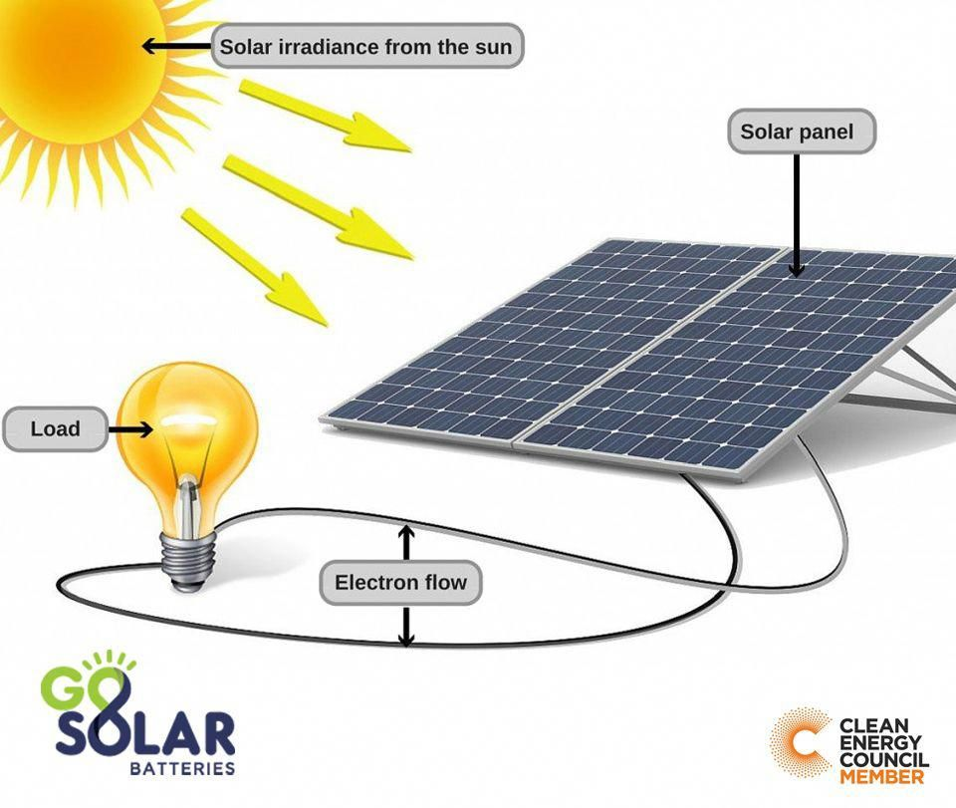

**Formation of solar energy**

**Food as a source of energy**

Food as a source of energy is important because;

* It helps us to grow
* It makes us healthy
* It keeps us strong
* It builds our body

**Activity: 15**

* + - 1. What is wind?

_______________________________________________________________________

* + - 1. Outline three activities that require the use of wind energy.

1. ____________________________________________________________________
2. ____________________________________________________________________
3. ____________________________________________________________________
   * + 1. State any two advantages of wind to man.
4. ____________________________________________________________________
5. ____________________________________________________________________
   * + 1. Why is water regarded as a source of energy?

_______________________________________________________________________

* + - 1. Mention two uses of water to a farmer.

1. ____________________________________________________________________
2. ____________________________________________________________________
   * + 1. Draw the main natural source of heat and light in the space below.
       2. Outline three forms of energy from the sun?
3. ____________________________________________________________________
4. ____________________________________________________________________
5. ____________________________________________________________________
   * + 1. Why are solar panels placed on top of the roofs?

_______________________________________________________________________

* + - 1. How is energy from the sun useful to plants?

_______________________________________________________________________

* + - 1. Give a reason why food is called a source of energy.

_______________________________________________________________________

**Artificial sources of energy**

Artificial sources are sources of energy made by man.

They include;

* Fuel
* Electricity

**Diagrams showing the artificial sources of energy**

|  |  |
| --- | --- |
| Booster raises $20 million to fill your car at work | TechCrunch | Ensuring transmission grid stability as the power generation mix changes |  T&D World |
| **Fuel** | **Electricity** |

* **Fuel**

Fuel is anything that burns to produce heat energy.

**Examples of fuels are;**

* diesel
* petrol
* wood
* coal
* natural gas
* paraffin
* firewood

**Fuels are grouped in to two;**

* + 1. **Liquid fuels**

Liquid fuels are fuels in liquid form. Examples are;

* petrol
* diesel
* kerosene
* aviation fuel
  + 1. **Solid fuels**

Solid fuels are fuels in solid form. Examples are;

* charcoal
* fire wood
* sawdust

**Note**: liquid fuels are fuels in liquid form.

Solid fuels are fuels in solid form.

|  |  |
| --- | --- |
|  |  |
| **Charcoal** | **Fire wood** |
|  | |
| **Sawdust** | |

**Paraffin**

Paraffin has the following uses;

* Paraffin is used for lighting lamps (lantern lamps)
* It is used for lighting charcoal stoves.
* Charcoal is used for burning rubbish.

**Charcoal**

Charcoal is a black substances made by burning wood in limited supply of air (oxygen).

Charcoal provides energy which is used for;

* Cooking food.
* Heating and melting metals.

**The uses of fuel**

* Petrol and diesel are used to run machines.
* Paraffin helps in cooking and lighting.
* Wood fuel is used to set up fire used for cooking.
* Charcoal helps to light charcoal stoves.

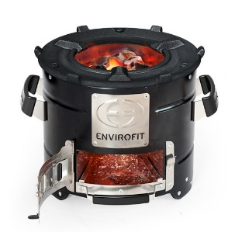

Charcoal is used for lighting charcoal stoves

**Activity: 16**

* + - 1. _________________________ are sources of energy that are made by man.
      2. Mention two artificial sources of energy?

1. _____________________________________________________________________
2. _____________________________________________________________________
   * + 1. What do you understand by the term fuel?

________________________________________________________________________

* + - 1. Outline four examples of fuel.

1. _____________________________________________________________________
2. _____________________________________________________________________
3. _____________________________________________________________________
4. _____________________________________________________________________
   * + 1. Give one example of solid fuel that is used at home.

_______________________________________________________________________

* + - 1. Outline two uses of each of the following.

1. Paraffin
2. _____________________________________________________________________
3. _____________________________________________________________________
4. Charcoal
5. _____________________________________________________________________
6. _____________________________________________________________________
   1. How is charcoal made?

________________________________________________________________________

* **Electricity**

Electricity is an artificial source of energy which is useful in very many ways.

**Uses of electricity**

* Electricity is used for running machines.
* It is used for cooking.
* It is used for washing.
* It is used for ironing clothes.
* Electricity is used for lighting in homes.
* It is used in hospitals to operate the sick.
* Electricity is used for charging batteries.

**Types of electricity**

1. **Hydroelectricity**

Hydro electricity is the type of electricity generated from fast flowing water.

The falling water in dams and rivers rotate blades of a turbine, which then spins the generator that converts mechanical energy of a spinning turbine into electrical energy.

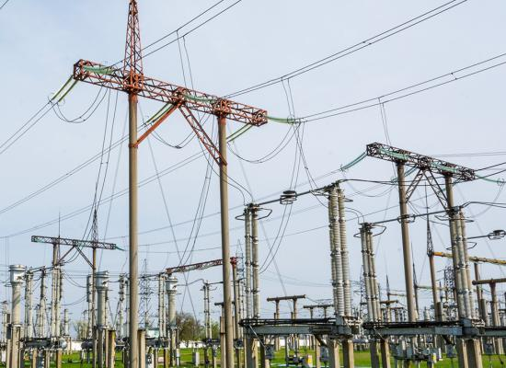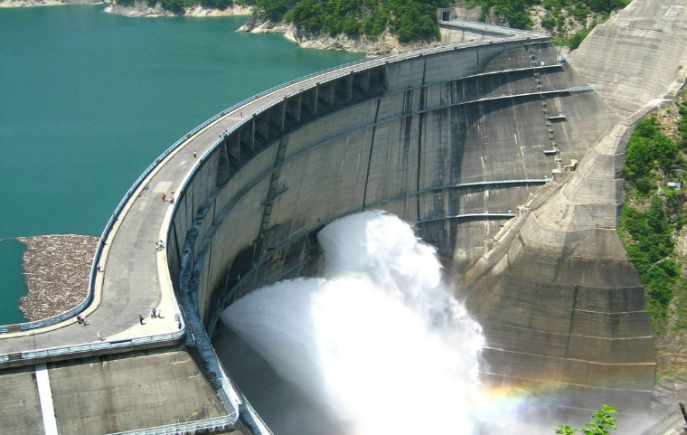

**Pictures showing the generation of hydroelectricity power**

1. **Solar electricity**

Solar electricity is the type of electricity generated from the sun.

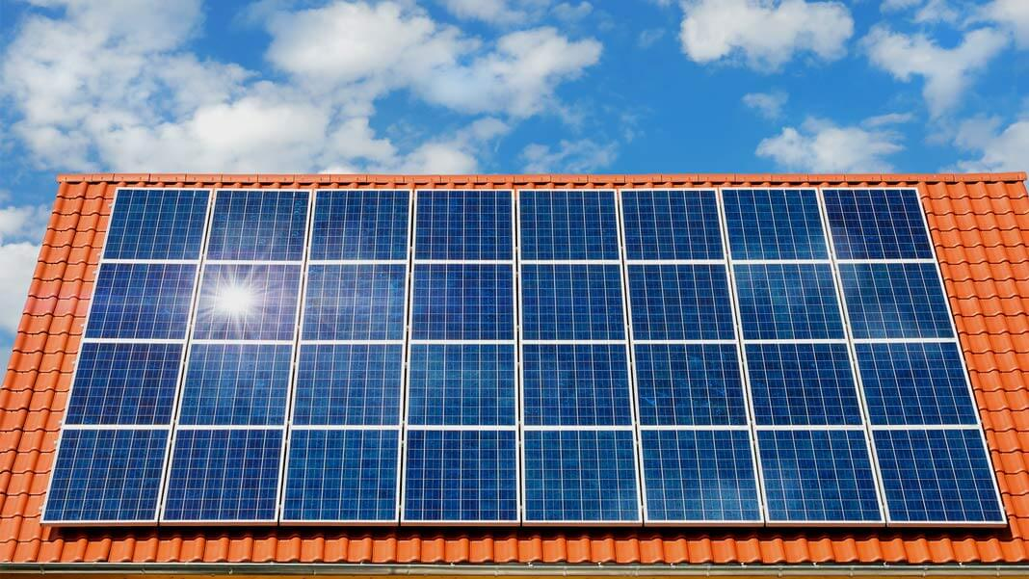

**Solar pannels on the roof**

1. **Thermal electricity**

Thermal electricity is the type of electricity generatedfrom burning fuel.

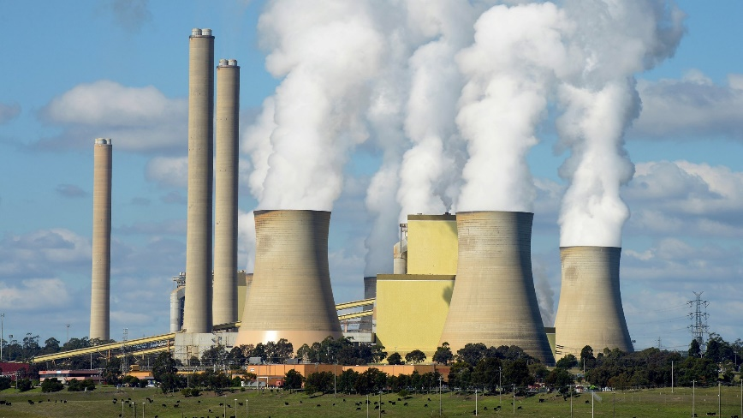

**Thermal electricity power plant**

**Things or appliances that use electricity**

* radios
* computers
* phones
* ovens
* refrigerators
* cookers

|  |  |  |
| --- | --- | --- |
| Sony XDRS60DBPB.CEK - XDRS60DBPB.CEK - XDR-S60 DAB+/DAB/FM Digital Radio:  Amazon.co.uk: TV | Multifunction Freestanding Dual Fuel Oven 90cm – OFS9020 – Ikon Commercial | **Computer Hardware Products - The Original PC Doctor** |
| **Radio** | **An oven** | **Computer** |

**Dangers of electricity**

* Electricity shocks people
* Electricity can burn houses
* It can burn or spoil machines

**How to conserve /save energy**

The following are the ways of conserving energy.

* By using energy saving bulbs, stoves, etc.
* By planting trees.
* By switching off electric appliances when not in use.
* By putting off fire when not in use.
* By following instructions on proper use of energy resources.
* By using other sources of energy like solar electricity.

**The Importance of saving energy include;**

* Saving energy prevents wastage of resources.
* It preserves energy for future use.
* It reduces or minimise costs hence saving money.
* Saving energy prevents destruction of the environment.

**Importance of planting trees (afforestation)**

* Trees control soil erosion.
* They help in rain formation.
* Trees provide people with timber.
* They provide people with firewood.
* Trees are habitats for wild animals.
* They reduce on the speed of strong wind.

**Activity: 17**

* + 1. Outline three uses of electricity.

1. _____________________________________________________________________
2. _____________________________________________________________________
3. _____________________________________________________________________
   * 1. Mention three types of electricity.
4. _____________________________________________________________________
5. _____________________________________________________________________
6. _____________________________________________________________________
   * 1. What name is given to electricity generated from fast flowing water?

________________________________________________________________________

* + 1. Define solar electricity.

________________________________________________________________________

* + 1. How is thermal electricity formed?

________________________________________________________________________

* + 1. What are electrical appliances?

________________________________________________________________________

* + 1. Draw and name any two electrical appliances in the space below.

|  |  |
| --- | --- |
|  |  |
|  |  |

* + 1. State three importance of saving energy.

1. _____________________________________________________________________
2. _____________________________________________________________________
3. _____________________________________________________________________
   * 1. Mention any three dangers of electricity at home.
4. _____________________________________________________________________
5. _____________________________________________________________________
6. _____________________________________________________________________

**Dangers of energy and ways of controlling them**

**Dangers of energy include;**

* Live wires can shock and kill people and animals.
* Short circuits can cause electric fire.
* Strong wind blows off roofs from houses and breaks trees.
* Storms and droughts cause death because they destroy crops leading to famine.
* Strong wind destroys crops from the garden.

**How to prevent dangers of energy**

* By avoiding playing with fire.
* By avoiding playing with electric wires.
* By planting trees.
* By making caution posters like; keep away from fire places, avoid touching electric wires with naked hands etc.
* By using fire extinguisher to put off fire in case of fire outbreak.

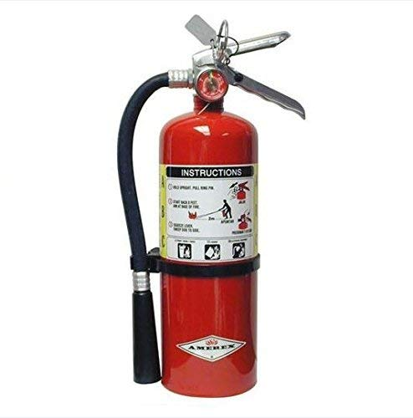**Diagram of fire extinguisher**

**Summary of dangers of energy and their control measures**

|  |  |
| --- | --- |
| **Dangers** | **Ways of control** |
| **Electric shocks** | Insulate wires |
| **Fire out break** | Proper use of fire  Use fire extinguishers |
| **Strong wind** | Plant trees  Construct strong buildings |
| **Drought** | Plant trees  Irrigate land |
| **Floods** | Dig wide channels |
| **Famine** | Plant more food crops  Store food for future use |

**Activity: 18**

* + - 1. Mention any four dangers of energy.

1. ______________________________________________________________________
2. ______________________________________________________________________
3. ______________________________________________________________________
4. ______________________________________________________________________
   * + 1. How can we prevent the dangers of energy?
5. ______________________________________________________________________
6. ______________________________________________________________________
7. ______________________________________________________________________
   * + 1. What name is given to a machine that is used to put off fire in case of fire out break?

________________________________________________________________________

* + - 1. Draw a fire extinguisher in the space below.

|  |
| --- |
|  |

* + - 1. What causes drought?

________________________________________________________________________

* + - 1. State any two importance of afforestation.

1. ______________________________________________________________________
2. ______________________________________________________________________

**ACCIDENTS AND FIRST AID**

**What is an accident?**

An accident is a sudden happening that may cause harm or death to a person.

Or an accident is unexpected happening that causes harm or death to a person.

An accident can happen from anywhere at any time for example; an accident can happen at home, on the road, at school or on your way to school.

**Accidents at home**

The following are some the ways how accidents can occur at home.

* You can cut yourself with a knife, panga, razor blade etc.
* A child can fall in a pit latrine.
* A child can fall off a tree.
* You can fall into a ditch and get a fracture, sprain or dislocation, etc.

**Therefore, the following are common accidents at home**

* Cuts
* Drowning
* Poisoning
* Burns
* Bruises
* Scalds
* Fractures
* Electric shocks
* Food chocking
* Bites (insect and animal bites)

**Things that cause accidents at home**

* Sharp objects like knives, razor blades, broken bottles, nails and pins.
* Dry heat like fire, acid etc.
* Wet heat like tea, porridge, steam, etc.
* Poison for example rat poison, paraffin, jik, drugs (aspirin, magnesium, etc.)
* Swimming pools, bath tubs, ponds, etc.

**What causes accidents at home?**

* Carelessness
* Climbing trees
* Playing with sharp objects
* Playing near water bodies
* Playing near fire
* Fighting
* Running
* Playing with electric
* Wires

**How can we control accidents at home?**

* Avoid over running.
* Avoid playing near water bodies.
* Avoid playing near fire.
* Avoid climbing trees.
* Follow the instructions always like “keep away from fire places”.
* Avoid playing with electric appliances like flat iron.

**Activity: 19**

* + - * 1. What is an accident?

________________________________________________________________________

* + - * 1. Mention any three common accidents at home.

1. _____________________________________________________________________
2. _____________________________________________________________________
3. _____________________________________________________________________
   * + - 1. Outline four things that cause accidents at home.
4. _____________________________________________________________________
5. _____________________________________________________________________
6. _____________________________________________________________________
7. _____________________________________________________________________
   * + - 1. What causes accidents at home?

________________________________________________________________________

* + - * 1. As a primary three child, what advice can you give to your siblings at home in order to prevent accidents?

________________________________________________________________________

* + - * 1. Draw a child falling off a tree in the space below.

|  |
| --- |
|  |

**Accidents at school**

These are accidents that can happen at school.

**Examples of common accidents at school include;**

* cuts
* burns
* scalds
* electric shocks
* drowning
* bruises
* fractures
* snake bites

**What causes accidents at school?**

* Playing rough games.
* Unnecessary running.
* Playing with sharp objects like razor blades.
* Fighting
* Playing near water bodies.
* Climbing trees.

**How can one prevent accidents at school?**

* Avoid playing with sharp objects.
* Avoid playing with or near hot things.
* Avoid unnecessary running.
* Avoid playing rough games.
* Follow rules and regulations.

**Accidents on the road**

These are accidents that can happen on the road.

Accidents on the road can also be called road traffic accidents.

Road traffic accidents can happen to different road users like;

* Pedestrians
* Cyclists
* Drivers
* Animals

**Examples of road traffic injuries are;**

* fractures
* bruises
* wounds
* deep cuts

**Question**

**What causes road traffic accidents?**

**Causes of accidents on the road**

* carelessness
* Speeding of vehicles
* Driving when drunk
* Driving vehicles in poor mechanical condition.
* Playing on the road.
* Poor roads.
* Over taking in corners
* Over loading of vehicles.

**How can we control road traffic accidents?**

We can control road traffic accidents in the following ways;

* Avoid over speeding of vehicles.
* By following traffic rules.
* Avoid over loading.
* Avoid over taking in corners.
* Do not drive when drunk.
* By repairing poor roads.
* Do not drive vehicles in poor mechanical condition.

**Activity: 20**

Mention any four common accidents at school.

1. ______________________________________________________________________
2. ______________________________________________________________________
3. ______________________________________________________________________
4. ______________________________________________________________________

Outline any two causes of accidents at school.

1. ______________________________________________________________________
2. ______________________________________________________________________

How does unnecessary running cause accidents at school?

_________________________________________________________________________

Why is it good to follow rules and regulations at school?

_________________________________________________________________________

Give one way of preventing snake bites at school?

_________________________________________________________________________

What are road traffic accidents?

_________________________________________________________________________

Mention any two common accidents on the road.

1. ______________________________________________________________________
2. ______________________________________________________________________

How can we control road traffic accidents?

_________________________________________________________________________

**FIRS AID**

First aid is the first help given to a person who has got an accident before being taken to the hospital.

**Or**. First aid is an immediate help given to a casualty before being taken to a health Centre to save life.

**A casualty** is person who has been injured.

Or; a casualty is a person who has got an accident.

**Reasons for giving first aid are;**

**Note: The main reason for giving first aid is to save life.**

* To save life.
* To reduce pain.
* To stop bleeding if any.
* To prevent further injuries.
* To promote quick recovery.

**A first aider**

A first aider is a person who gives first aid to a casualty.

**What are the qualities of a good first aider?**

* A good first aider should be quick (fast).
* A good first aider should be clean.
* A god first aider should be knowledgeable.
* He/she should be humble or polite.
* A good first aider should be sympathetic.

**First aid box**

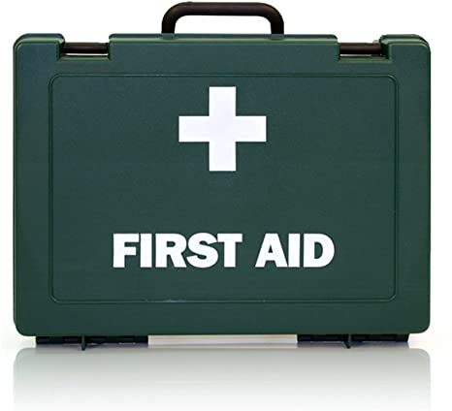First aid box is a box where first aid items are kept.

**Diagram of a first aid box**

**A first aid kit**

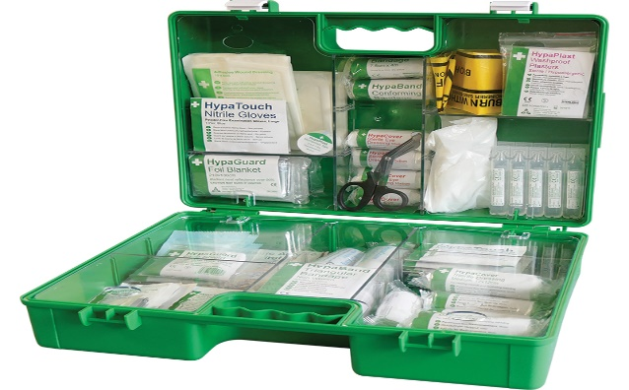A first aid kit is a collection of items used for giving first aid to a casualty.

**Mention the things or items found in a first aid box.**

* bandages
* iodine
* spirit
* pain killers
* razor blades
* A pair of scissors
* gauze
* plaster
* cotton wool
* gloves

|  |  |  |
| --- | --- | --- |
| Medical Bandages at Rs 100/unit | मेडिकल बैंडेज - Sindhoori Surgicals,  Hyderabad | ID: 2994692891 | Iodine Antiseptic Solution | Specialist Sales |  |
| **Bandage** | **Iodine** | **Gauze** |
| Top Nitrile gloves Manufacturers and Suppliers in the USA | 1 PAIR OF STEROPLAST MEDICAL NURSES STAINLESS STEEL FIRST AID SAFETY SHARP  TIPPED SCISSORS: Amazon.co.uk: Sports & Outdoors | **C:\Users\RJS\AppData\Local\Microsoft\Windows\INetCache\Content.MSO\9EB9DF71.tmp** |
| **Gloves** | **Pair of scissors** | **Cotton wool** |

**Give the uses of some the above items to a first aider.**

* Bandage: It is used to tie a broken bones in their right position.
* Iodine or spirit: It is used to wash and kill germs on wounds and cuts.
* Cotton wool: It is used to wash cuts and wounds
* Plaster: It is used to cut bandages and plasters.
* Pain killers: pain killers are used to reduce pain.

**Activity: 21**

Define first aid.

__________________________________________________________________________

What name is given to a person who has got an accident?

__________________________________________________________________________

Why do we give first aid to a casualty?

__________________________________________________________________________

Who is a first aider?

__________________________________________________________________________

Outline three qualities of a good first aider.

1. ________________________________________________________________________
2. ________________________________________________________________________
3. ________________________________________________________________________

Differentiate between a first aid box and a first aid kit.

____________________________________________________________________________________________________________________________________________________

Name the uses of the following things found in a first aid box.

1. Bandage

________________________________________________________________________

1. Pair of scissors

________________________________________________________________________

1. Pain killers

________________________________________________________________________

Draw a first aid box in the space below.

|  |
| --- |
|  |

Mention any two places where a first aid box can be found.

1. ___________________________________ ii)________________________________

**First aid for simple accidents**

1. **Burns**

Dip the burn in cold water.

1. **Scalds**

Dip the scald in cold water.

1. **Cuts**

Wash the cut with clean cold water.

1. **Fractures**

A fracture is a broken bone in the body.

Its first aid is: Tie the broken bone with a bandage or splints.

1. **Nose bleeding**

Pinch the nose and bend forward

1. **Drowning**

Remove the casualty from the water and let him lie on his or her back then start mouth to mouth breathing (kiss of life).

**New words learnt**

* accident
* traffic
* fractures
* bruises
* choke
* kit
* poisoning
* recovery
* burns
* sudden
* bleeding
* injury
* mechanical
* drowning
* first aid
* casualty
* scalds

**Work to enjoy**

Imagine your friend fell off a bicycle and got a fracture, write a simple procedure you can follow when giving first aid to him/her.

____________________________________________________________________________________________________________________________________________________________________________________________________________________________________________________________________________________________________________________